**Repository link :-** **https://github.com/pnimmagadda0404/ML_assignment-1**

**#Question 1**

Output is shown in Fig 1.2

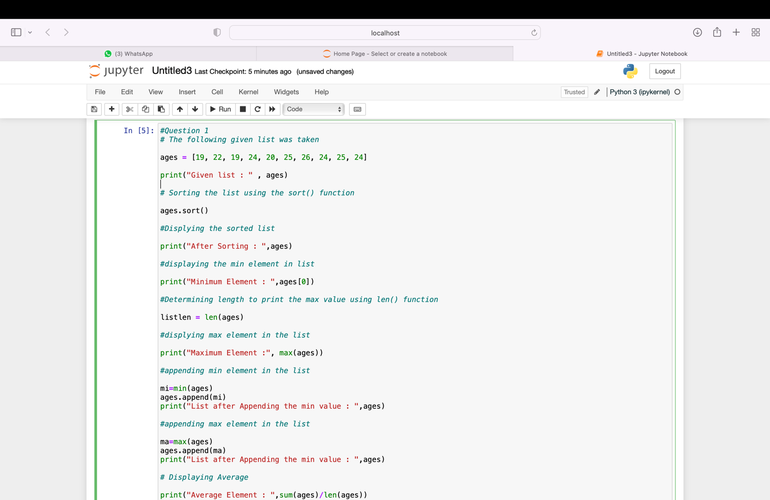

**Fig 1.1**

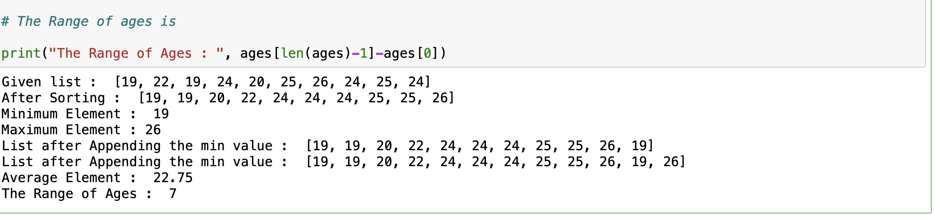

**Fig 1.2**

**Explanation:**

1. Declared the list named ages and assigned.
2. Sorted the ages list by using **sort()** function.
3. Displayed the sorted list .
4. Displayed the minimum element in the sorted list by using **min()** function.
5. Determined the length to print the length of the list by using **len()** function.
6. Displayed the maximum element in the sorted list by using **max()** function.
7. Displayed the Average in the list by using **sum()** and **len()** functions **[sum(ages)/len(ages)].**
8. Finally Calculated the Range of the ages list by using **len()** function

[**ages[len(ages)-1]-ages[0]].**

**#Question 2**

Output is shown in Fig 2.2

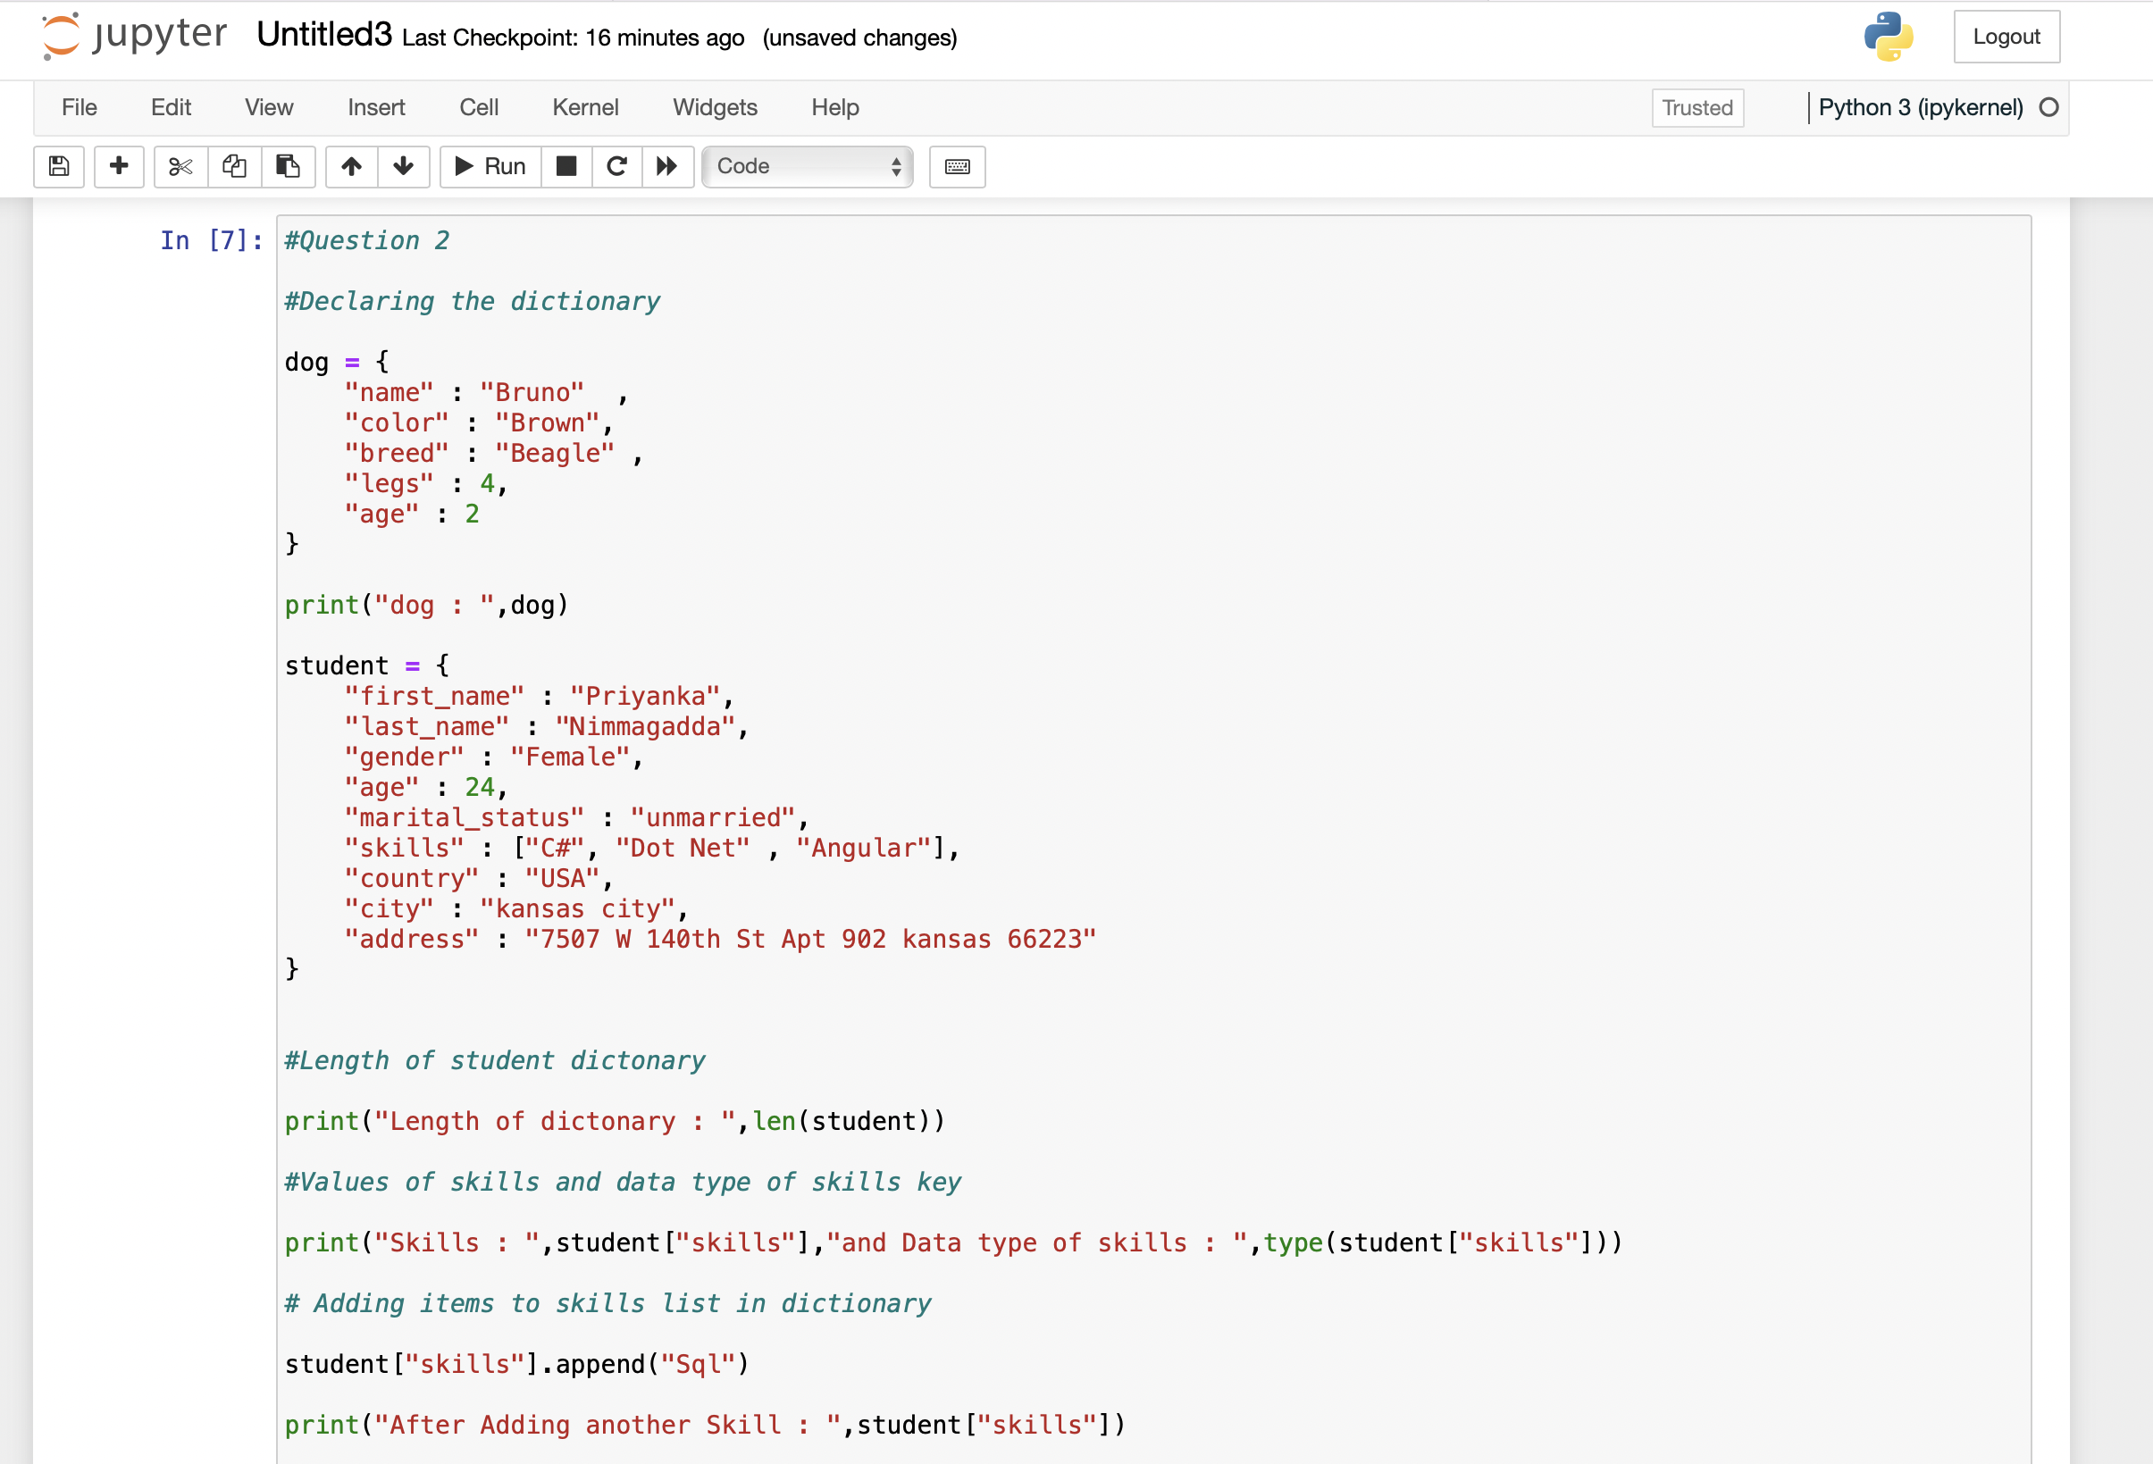

**Fig 2.1**

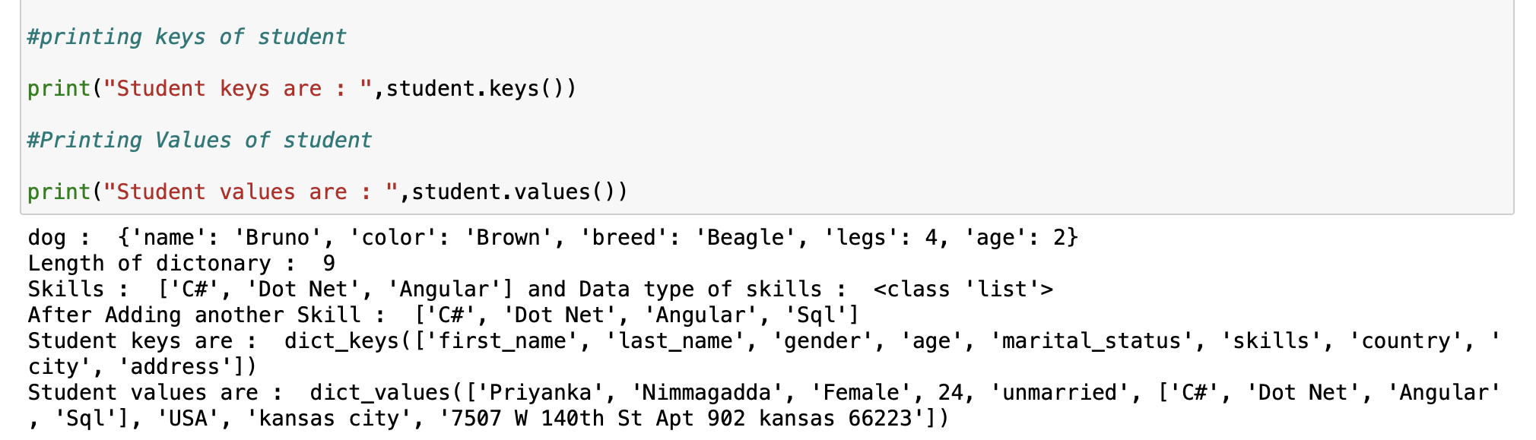

**Fig 2.2**

**Explaination:**

1.Create an empty dictionary called dog.

2.Add Name, Color, Breed, Legs, Age to the dictionary.

3.Create a Student dictionary and add first_nme, last_name,gender, age, martial status, skills, country, city and address as a key for the dictionary.

4.Get the length of the student dictionary.

5.Get the value of skills and check the data type, it should be a list.

6.Modify the skills values by adding one or two skills.

7.Get the dictionary keys as a list.

8.Get the dictionary values as a list

**# Question 3**

Output is shown in Fig 3.1

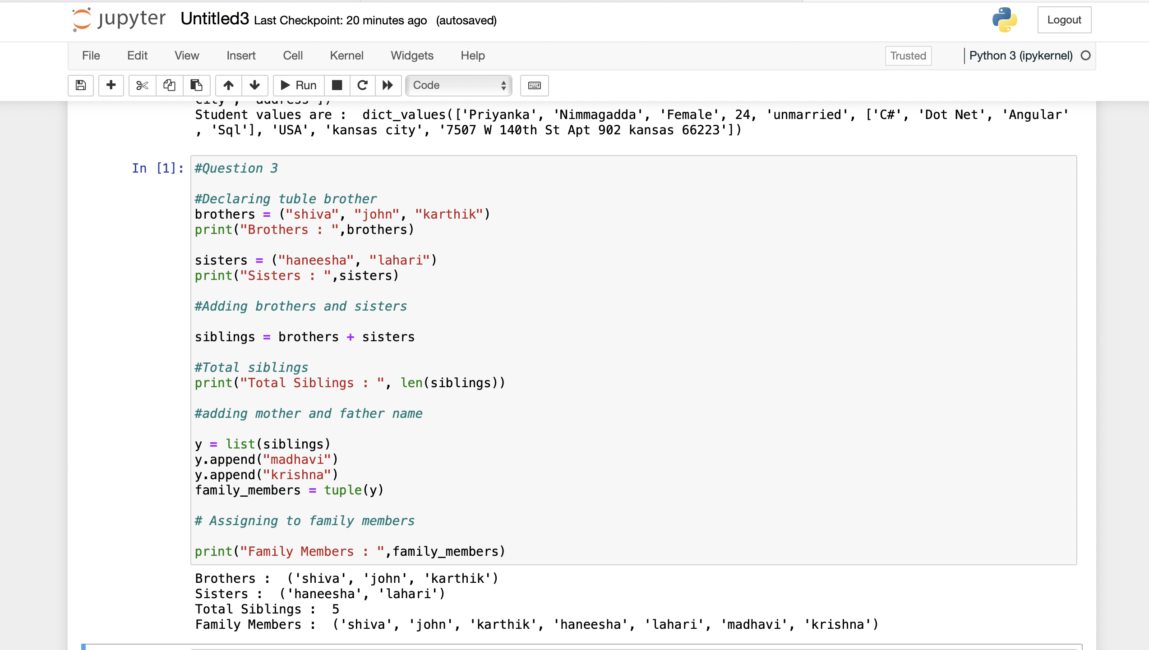

**Fig 3.1**

Explanation:

1.Tuple were created with 3 values in it as shown in Fig 3.1

2. Two Tuples were added using the **“+”** symbol.

3.Adding the mother and father name to the siblings tuple using the **append()** function.

**#Question 4**

Output is shown in Fig 4.4

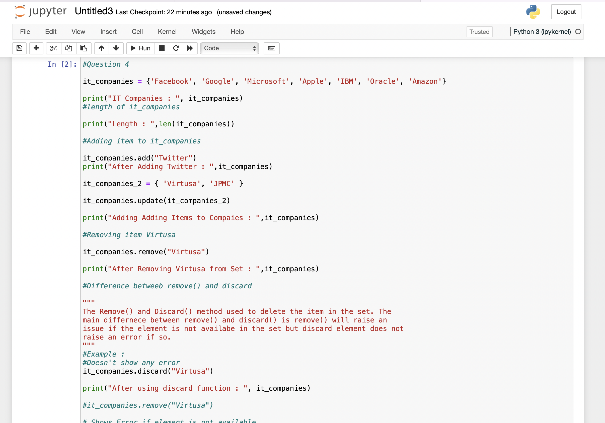

**Fig 4.1**

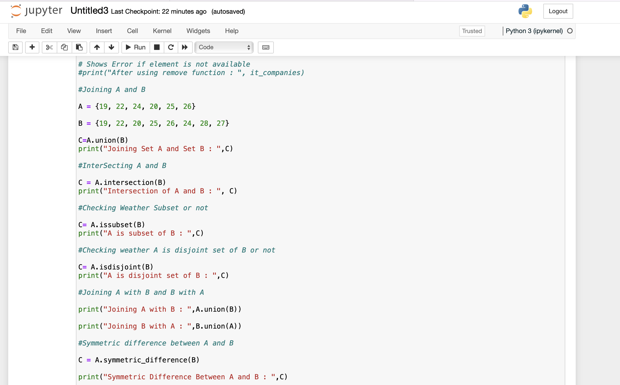

**Fig 4.2**

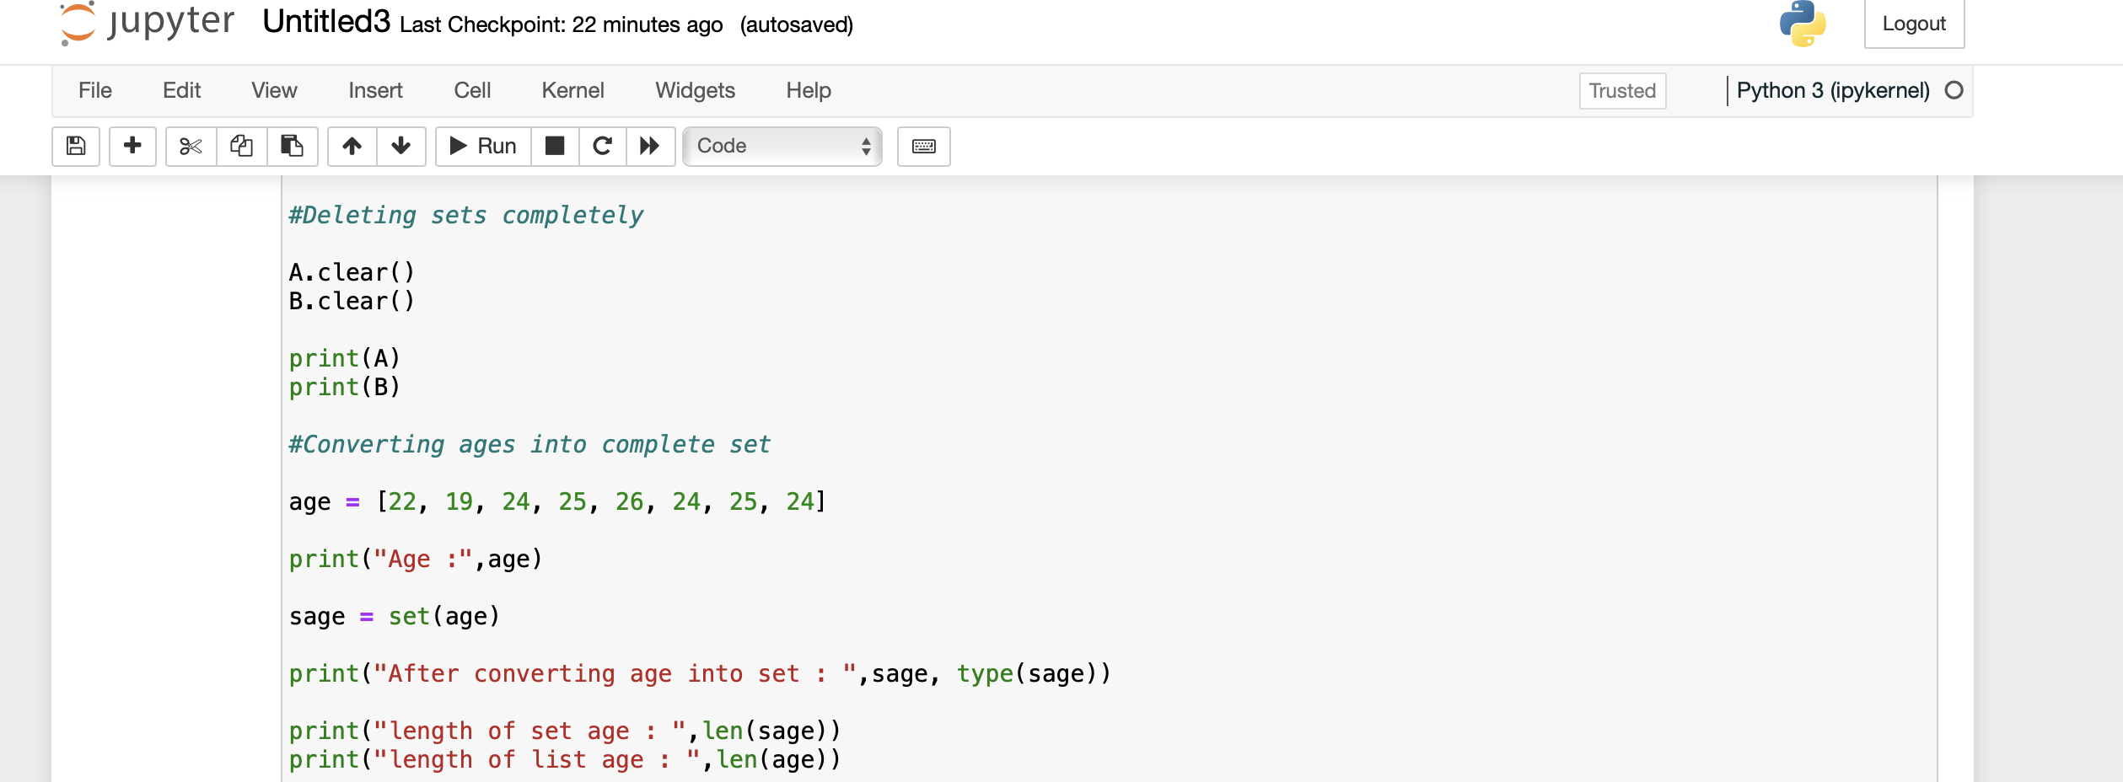

**Fig 4.3**

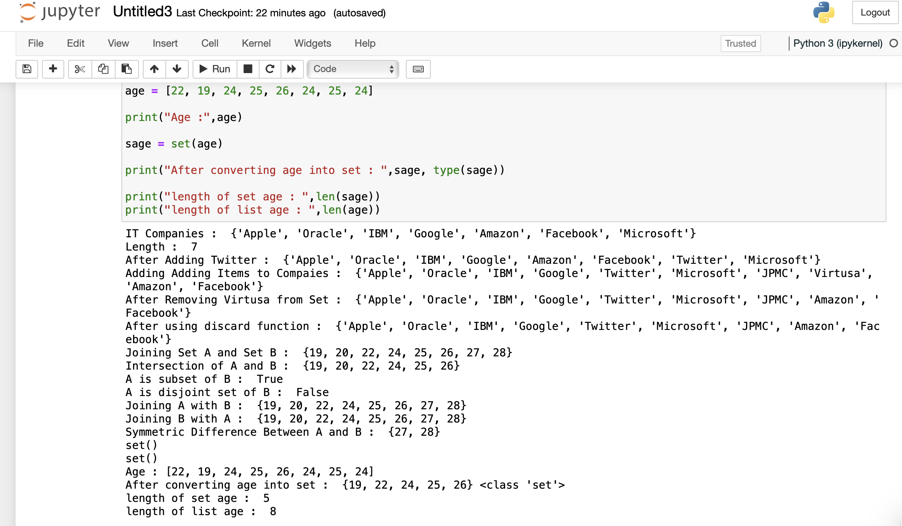

**Fig 4.4**

**Explaination:**

1.The given set declared below

it_companies = {'Facebook', 'Google', 'Microsoft', 'Apple', 'IBM', 'Oracle', 'Amazon'}

print("IT Companies: ", it_companies)

2.Length of the set is found using the **len()** function.

print("Length : ",len(it_companies))

3.New Items are added to the Set using the **add()** function.

it_companies.add("Twitter")

print("After Adding Twitter: ",it_companies)

4.Declaring new Set

it_companies_2 = { 'Virtusa', 'JPMC' }

5.updating the old set (it_companies) with new set (it_companies_2) using update function

it_companies.update(it_companies_2)

print("Adding Adding Items to Compaies : ",it_companies)

6.Item can be removed from the Set using the remove function. Virtusa is removed from yje

it_companies.remove("Virtusa")

print("After Removing Virtusa from Set : ",it_companies)

7.Difference between remove () and discard is as follows

The **Remove ()** and **Discard ()** method used to delete the item in the set. The

main difference between **remove ()** and **discard ()** is **remove ()** will raise an

issue if the element is not available in the set but discard element does not

raise an error if so.

"""

**#Example:**

#Doesn't show any error

it_companies.discard("Virtusa")

print("After using discard function : ", it_companies)

#it_companies.remove("Virtusa")

# Shows Error if element is not available

#print ("After using remove function: ", it_companies)

Set A and Set B is declared as below

A = {19, 22, 24, 20, 25, 26}

B = {19, 22, 20, 25, 26, 24, 28, 27}

8.Two sets are joined using the union function. The elements in both sets are assigned to another set below. Common elements are assigned only once after the union elements

C=A.union(B)

print ("Joining Set A and Set B: “, C)

9.Intersection between two sets can be found using the intersection () function. Only common elements are assigned after the intersection operation.

C = A.intersection(B)

print("Intersection of A and B : ", C)

10.The issubset() function is used to determin wheather a function is subset or not. This Function gives the true or false as return values.

C= A.issubset(B)

print("A is subset of B : ",C)

11.The isdisjoint () function is used to determin wheather a function is disjoint or not. This Function gives the true or false as return values.

C= A.isdisjoint(B)

print("A is disjoint set of B : ",C)

union is used to join the two sets.

print("Joining A with B : ",A.union(B))

print("Joining B with A : ",B.union(A))

12.**Symmetric_difference()** is used to check the symmetric difference between two function. This method returns all the methods in the set except the intersection elements.

**C = A.symmetric_difference(B)**

print("Symmetric Difference Between A and B : ",C)

13.Clear method is used to delete the elements in the Set. It removes all the elements in the Set.

A.clear()

B.clear()

print(A)

print(B)

The Age Set is declared as below

age = [22, 19, 24, 25, 26, 24, 25, 24]

print("Age :",age)

14.Typecasting is a method of converting object of one type to another type. Here the list is converted into the age

sage = set(age)

print("After converting age into set : ",sage, type(sage))

15.The length of list before converting and length after converting is shown using the **len()** function.

print("length of set age : ",len(sage))

print("length of list age : ",len(age))

**#Question 5**

Output is shown in Fig 5.1

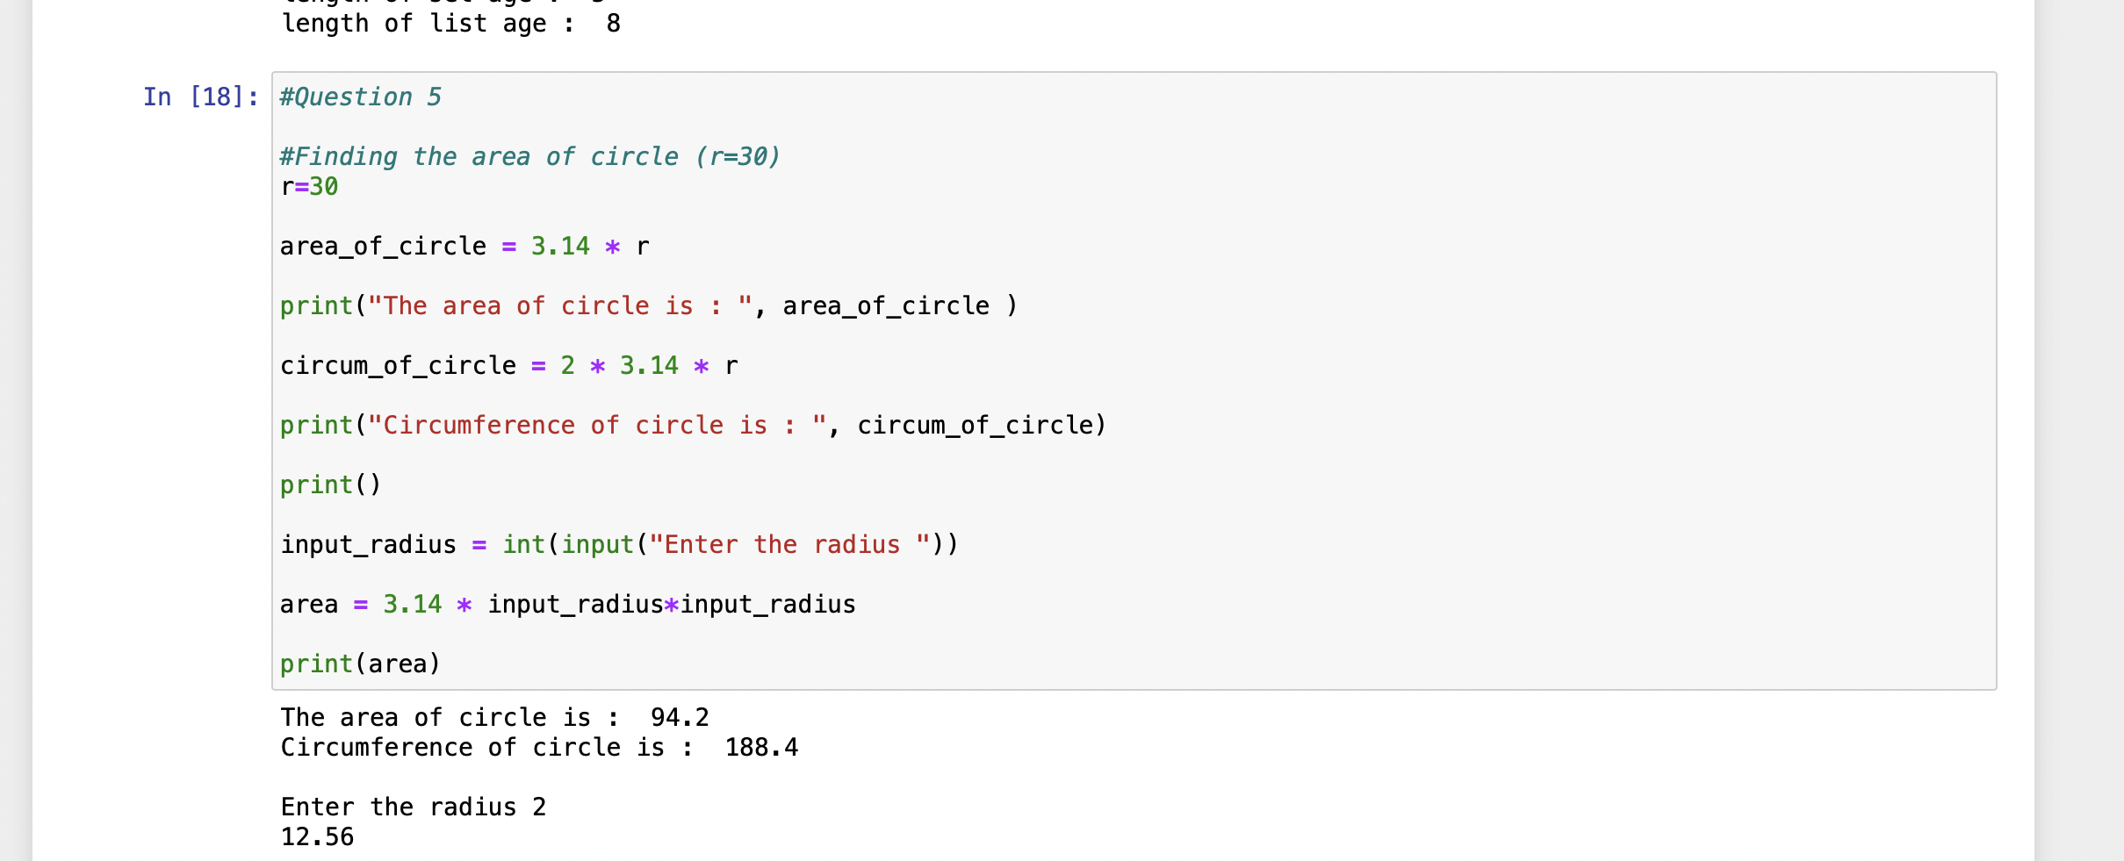

Fig 5.1

**Explanation:**

1.The radius of the circle is declared below with r as variable.

r=30

2.The area of circle is  **πr^2** . The calculation is done as below

area_of_circle = **3.14 * r^2**

print("The area of circle is : ", area_of_circle )

3.The circumference of circle is **2πr.**

circum_of_circle = **2 * 3.14 * r**

print("Circumference of circle is : ", circum_of_circle)

print()

4.The input() is used to take the input from the user. The type casting is done as per the requirement of the user.

input_radius = int(input("Enter the radius "))

5.Area of circle is πr^2.

area = 3.14 * input_radius

print(area)

**#Question 6**

Output is shown in Fig 6.1

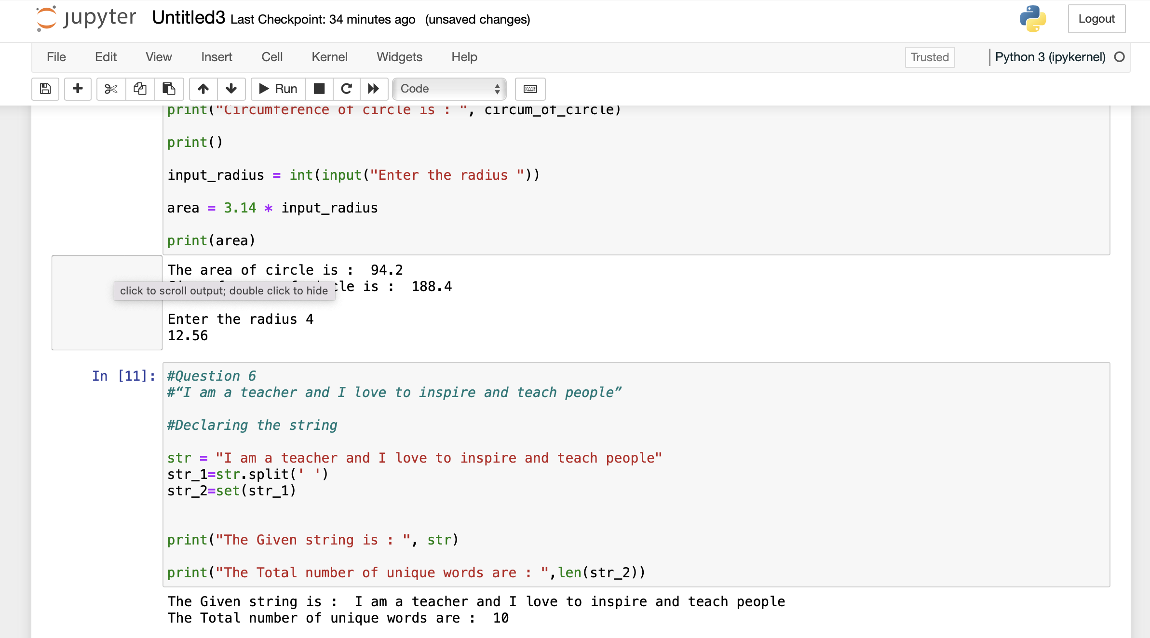

**Fig 6.1**

**Explanation:**

1.The given string is declared using the str varible.

str = "I am a teacher and I love to inspire and teach people"

print("The Given string is : ", str)

2.The unique words are displayed using the set, list type casting. And therefore the count is taken from the number of elements available in the list after typecasting

**Str_1=str.split(‘ ’)**

**Str_2=set(str_1)**

**Print(len(str_2)**

**#Question 7**

Output is shown in Fig 7.1

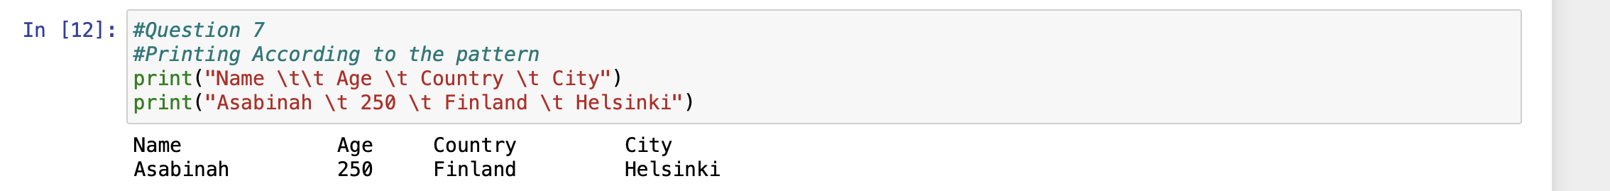

**Fig 7.1**

**Explanation:**

1.\t is used to print the tab space just like the \n used for the new line. According to the required pattern in the question the appropriate \t are placed where ever required. \t\t gives two tab spaces.

print("Name \t\t Age \t Country \t City")

print("Asabinah \t 250 \t Finland \t Helsinki")

**#Question 8**

Output is shown in Fig 8.1

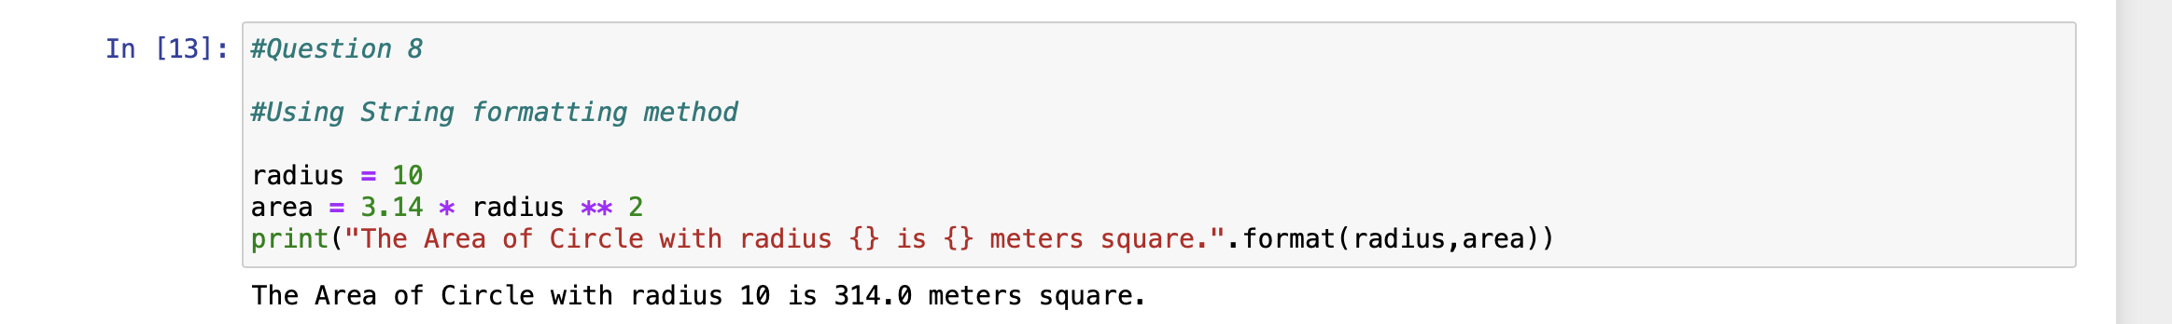

**Fig 8.1**

**Explanation:**

**1.Format()** function is used to format the values inside specific string’s placeholders.

Radius = 10

area = 3.14 * radius ** 2

print(“The Area of Circle with radius {} is {} meters square.”.**format(radius,area)**)

**#Question 9**

Output is shown in Fig 9.1

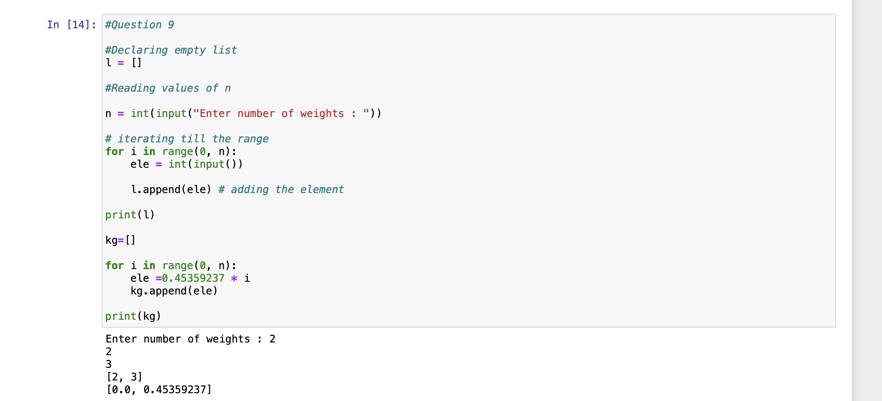

**Fig 9.1**

**Explanation:**

1.Declaring empty list as below

l = []

2.The number of valies in the list is read from the user as below.

n = int(input("Enter number of weights : "))

3.Taking the values from the user and assigning to the list using the input() and append()

for i in range(0, n):

ele = int(input())

l.append(ele) # adding the element

print(l)

4.Empty list for kg is declared as below.

kg=[]

**#Question 10**

**10 a. Data set**

Divide the **Data set** into **Train set** and **Test set**

**F label**

**Train set**

1. **1 1**
2. **2 1**
3. **3 0**
4. **6 0**

**Test set**

1. **6 0**
2. **7 1**
3. **10 1**
4. **11 1**

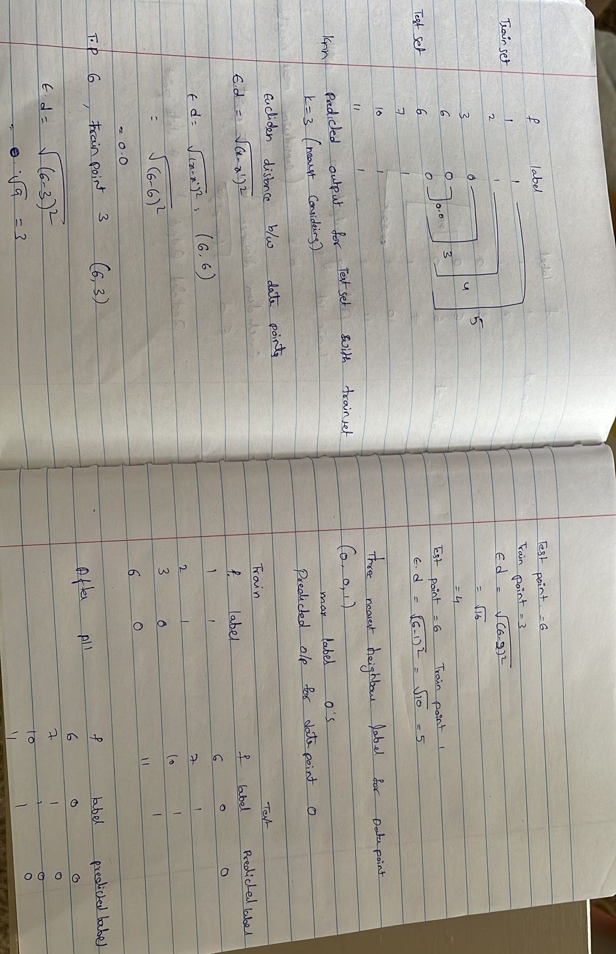

**10 b.**

